ASSIGNMENT # 08

**Cooling Tower**

**EXPERIMENT # 7:**

**Find The Effectiveness Of**

**COOLING TOWER**

**Introduction:**

* A **Cooling Tower** is a heat rejection device that rejects [waste heat](https://en.wikipedia.org/wiki/Waste_heat) to the [atmosphere](https://en.wikipedia.org/wiki/Atmosphere) through the cooling of a water stream to a lower temperature.

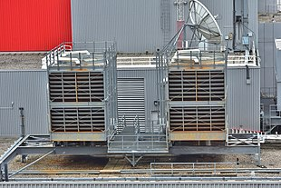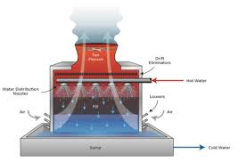**Diagram:**

**Principle:**

* **Cooling tower** is an important part of power plant. The basic working **principle of cooling tower** is to cool the hot water with the help of atmospheric air. ... Now the hot air in the **cooling tower** expose in the atmospheric air which reduces the temperature of the hot water by partial evaporation as shown in figure # 8-1.

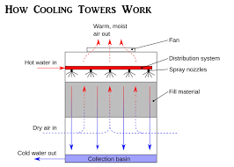 **Figure # 8-1:**

**Main Parts: (figure # 8-2)**

* + - * The **major cooling tower components** include
* Cold Water Basin
* **Cooling Tower** Structure
* Fills
* Drift eliminators  **Figure # 8-2:**
* **Cooling Tower** Fans,
* 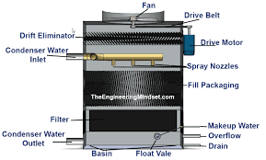Water Distribution Piping's
* Fan Deck & Fan cylinder
* **Cooling Tower** Louvers,
* Gear box
* Drive shafts & Mechanical Equipment Support
* Valves
* Nozzles
* Electrical & Instrumentation systems ...
* Flow Meter
* Heaters (1KW and 0.5KW)
* Air Distribution Chamber
* Anemometer

**Working Of Cooling Tower:**

* **Cooling Tower in HVAC**: **Cooling tower** is a peripheral equipment that removes heat from the hot water that is pumped from the condenser to the **tower**. It is done by using the air from the surrounding to reduce the temperature of the water. The air can be natural or forced by the use of fan.
* Cooling tower is peripheral equipment that removes heat from the hot water that is pumped from the condenser to the tower. It is done by using the air from the surrounding to reduce the temperature of the water. The air can be natural or forced by the use of fan. The capacity to cool the water depends on the evaporation of the water when air comes in contact with the water.

**Anemometers:**

* This **instrument** was **used to measure** the **velocity** of the **air** exiting the **cooling tower** fans. Several anemometers were **used** for each **cooling tower**.

**HVAC (heating, ventilating, and air conditioning):**

* 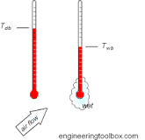**Cooling tower** is used to dispose of ("reject") Figure # 8-3:

Unwanted heat from a chiller. **Water**-cooled chillers are normally more energy efficient than air-cooled chillers due to heat rejection to **tower water** at or near wet-bulb temperatures as shown in figure # 8-3.

**Wet-bulb temperature:**

* The **wet**-**bulb temperature** (WBT) is the **temperature** read by a thermometer covered in water-soaked cloth (**wet**-**bulb** thermometer) over which air is passed. At 100% relative humidity, the **wet**-**bulb temperature** is equal to the air **temperature** (**dry**-**bulb temperature**) and it is lower at lower humidity.

**Wet-bulb temperature in Cooling Tower: Figure # 8-4:**

* 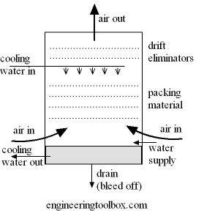78°F
* Most **cooling towers** are capacity rated at a "standard" **wet bulb temperature** of 78°F. That means on the days when the **wet bulb temperature** is 78°F, the **tower** will produce its stated capacity. In other words,a **tower** rated to produce 135 tons of **cooling** will produce 135 tons of **cooling** at a 78°F **wet bulb temperature** as shown in figure 8-4.

**Formula: Figure # 8-5:**

* 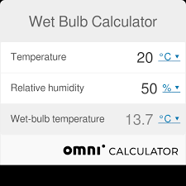A quick technique that many forecasters use to determine the **wet**-**bulb temperature** is called the "1/3 rule". The technique is to first find the dew point depression (**temperature** minus dew point). Then take this number and divide by 3. Subtract this number from the **temperature** as shown in figure # 8-5.

**Dry Bulb Temperature:**

* The **dry**-**bulb temperature** (DBT) is the **temperature** of air measured by a thermometer freely exposed to the air, but shielded from radiation and moisture. DBT is the **temperature** that is usually thought of as air **temperature**, and it is the true thermodynamic **temperature**.

**Dry Bulb Temperature in Cooling Tower:**

* A very important concept for understanding **cooling tower** heat transfer is that of “**wet bulb**” **temperature**. Consider being outdoors, but in the shade, on a 90 F day at 40 percent relative humidity. A standard thermometer would naturally read 90 F, which is the “**dry bulb**” **temperature**.

**Formula:**

* 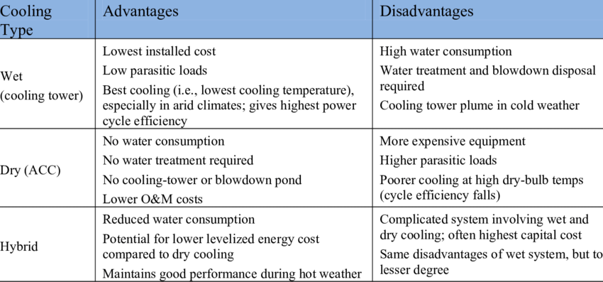**Dry**-**bulb temperature** - Tdb, can be measured using a normal thermometer freely exposed to the air but shielded from radiation and moisture. The **temperature** is usually given in degrees Celsius (oC) or degrees Fahrenheit (oF). The SI unit is Kelvin (K).
* **Graph Between Temperature AND Percent Distance To Tower:**

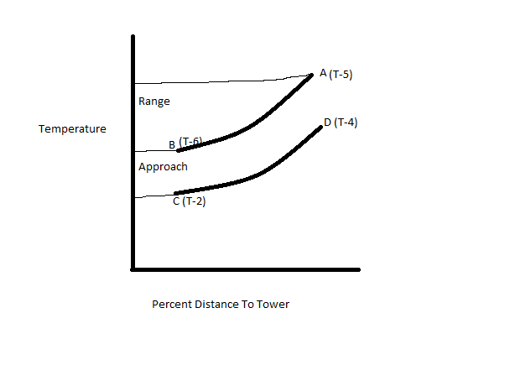

|  |  |
| --- | --- |
| **NAME(water flow rate=3litre/minute)**  **Speed of air = 4.2** | **VALUE** |
| **T1** =Dry bulb temperature of air at inlet | 13’C |
| **T2** =Wet bulb temperature of air at inlet | 14’C |
| **T3** =Dry bulb temperature of air at exit | 18’C |
| **T4** =Wet bulb temperature of air at exit | 20’C |
| **T5** =Water inlet temperature at top | 21’C |
| **T6** =Water outlet temperature at bottom | 17’C |
| **T7** =Temperature of makeup tank | 13’C |

|  |  |
| --- | --- |
| **NAME(water flow rate=6litre/minute)**  **Speed of air = 8.4** | **VALUE** |
| **T1** =Dry bulb temperature of air at inlet | 13’C |
| **T2** =Wet bulb temperature of air at inlet | 13’C |
| **T3** =Dry bulb temperature of air at exit | 18’C |
| **T4** =Wet bulb temperature of air at exit | 19’C |
| **T5** =Water inlet temperature at top | 20’C |
| **T6** =Water outlet temperature at bottom | 17’C |
| **T7** =Temperature of makeup tank | 13’C |

|  |  |
| --- | --- |
| Range=T5 –T6 =21’C-17’C =4’C    Approach=T6 –T2 =17’C-14’C =3’C | Range=T5 –T6 = 20’C – 17’C =3’C  Approach=T6 –T2 = 17’C -13’C=4’C |
| Effectiveness=Range/Range+ Approach*100  Effectiveness=4’C / 4’C + 3’C *100=57.14 % | Effectiveness=Range/Range+ Approach*100  Effectiveness=3’C / 3’C + 4’C *100=42.85 % | |

**Applications:**

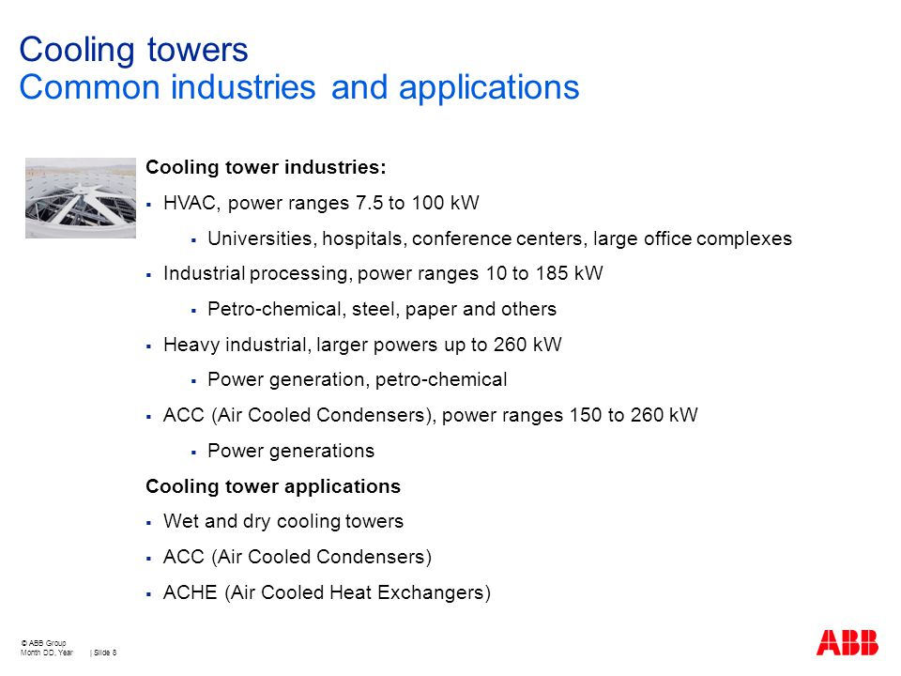

***“THANK YOU TEACHER FOR HELPING ME BLOOM”***